**UI, User, and testing**

**UI Design - Client and Carer Interface**

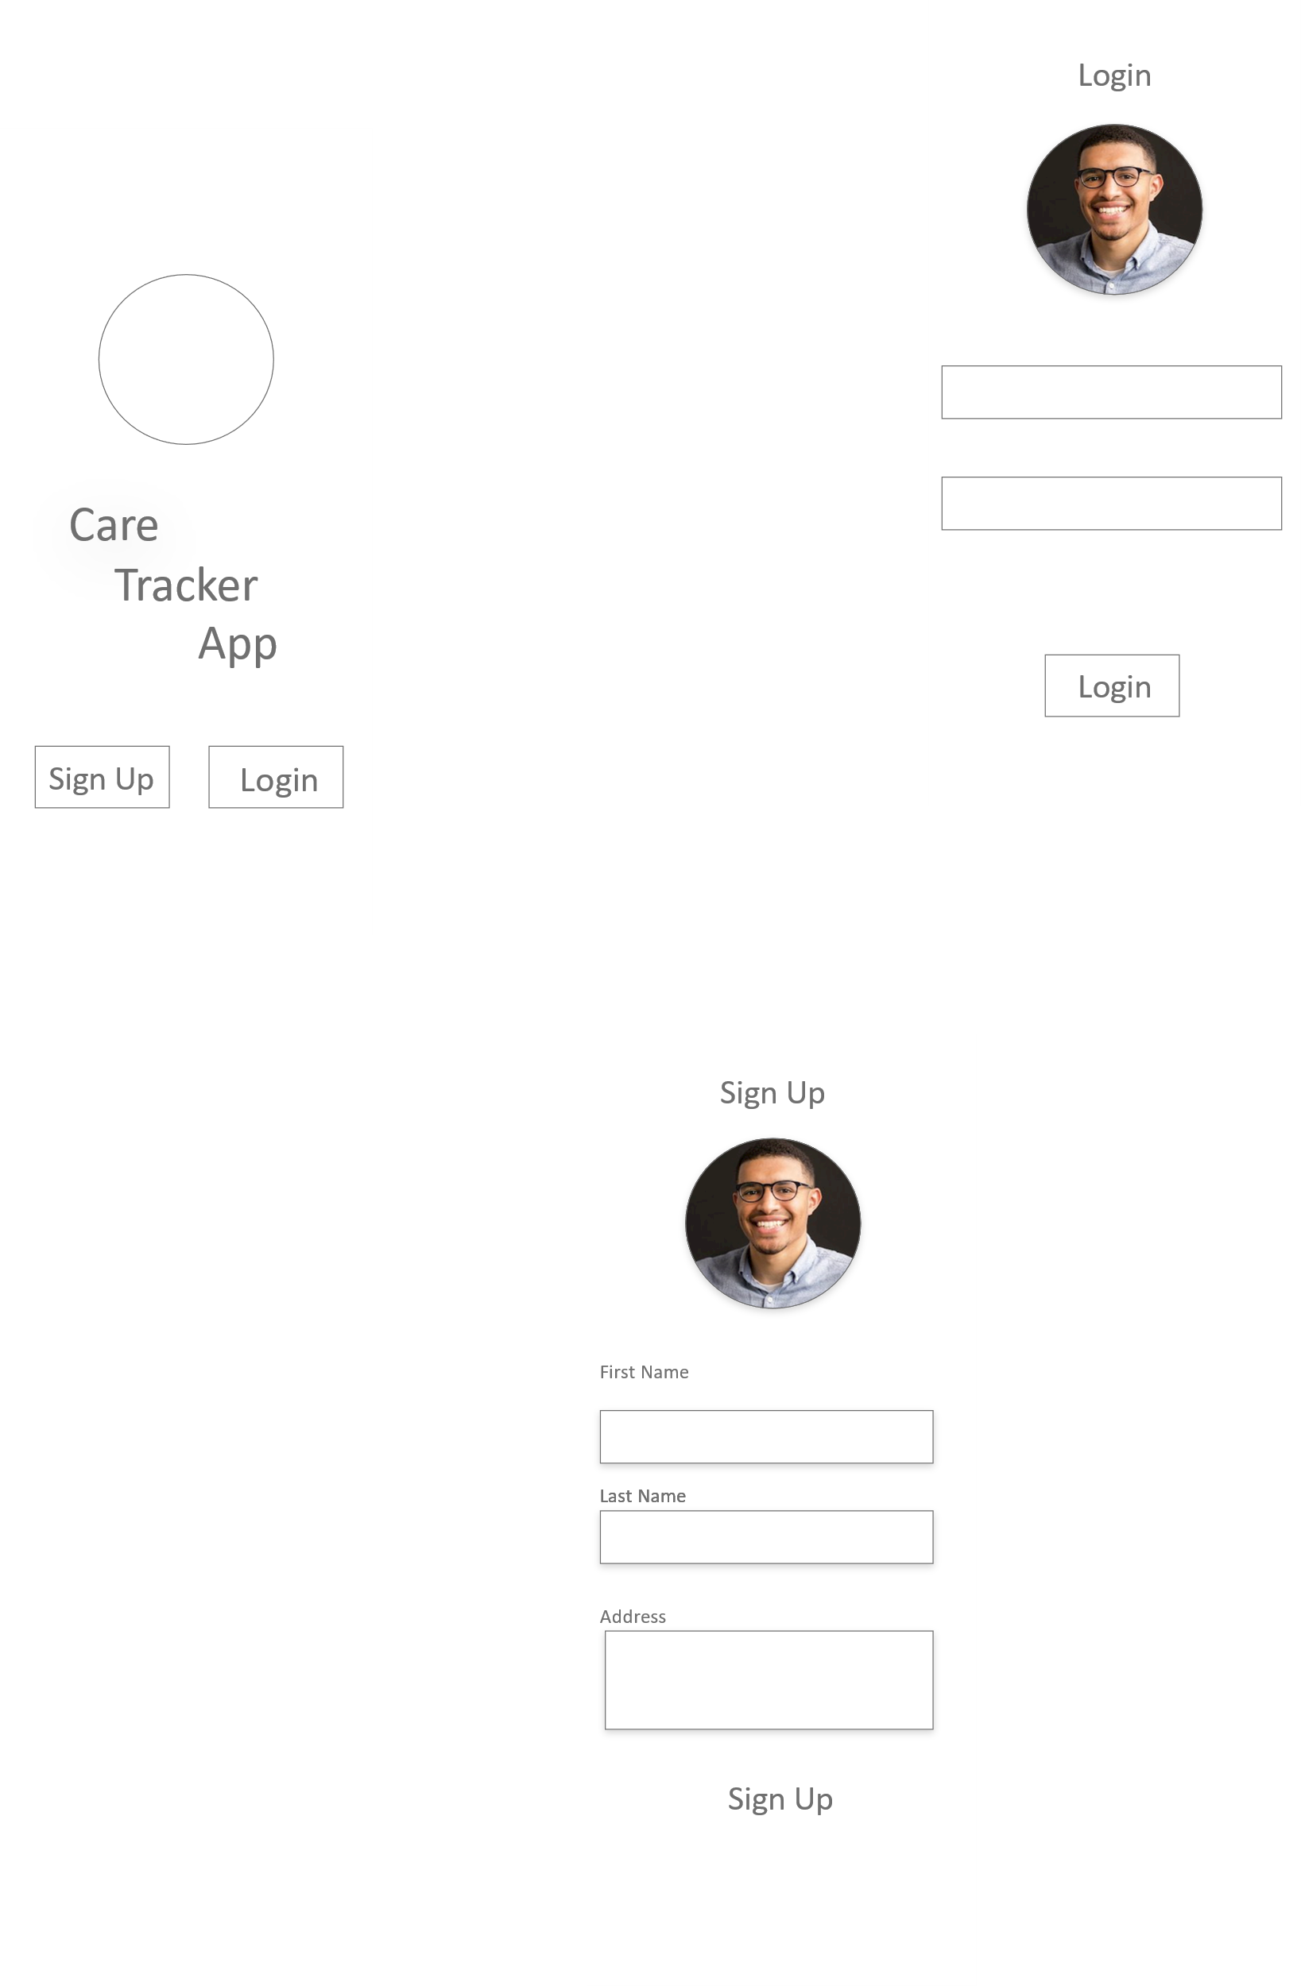

Once the user has now signed up, he can login to use his account

Sign Up

The user is asked to sign up with their details

Login

The user is told to Login if he has his details

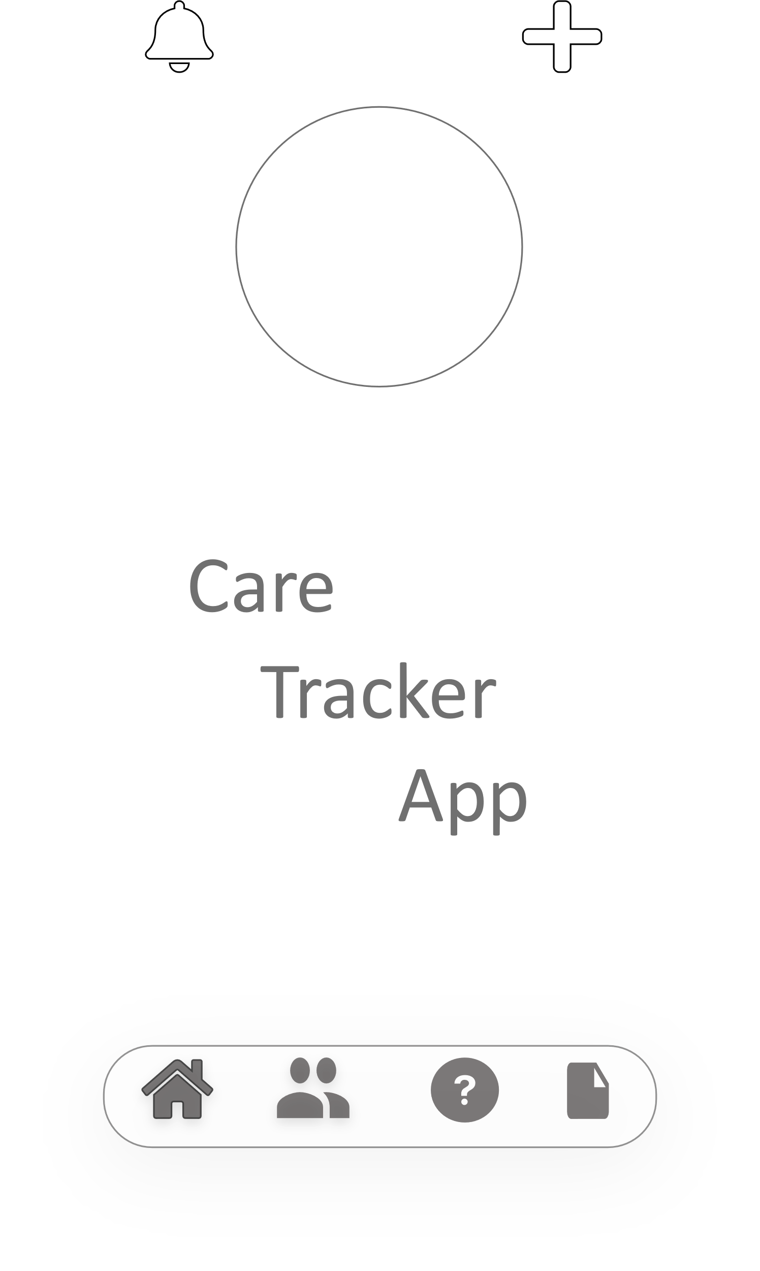

The is the Home interface for the Client using the navigation bar split onto their respective parts including

* Home
* Profile
* Help
* Planner

Icons such as the bell takes you to view the notification and the plus sign is used as a shortcut to add a activity to the planner

Planner

Help

Profile

Home

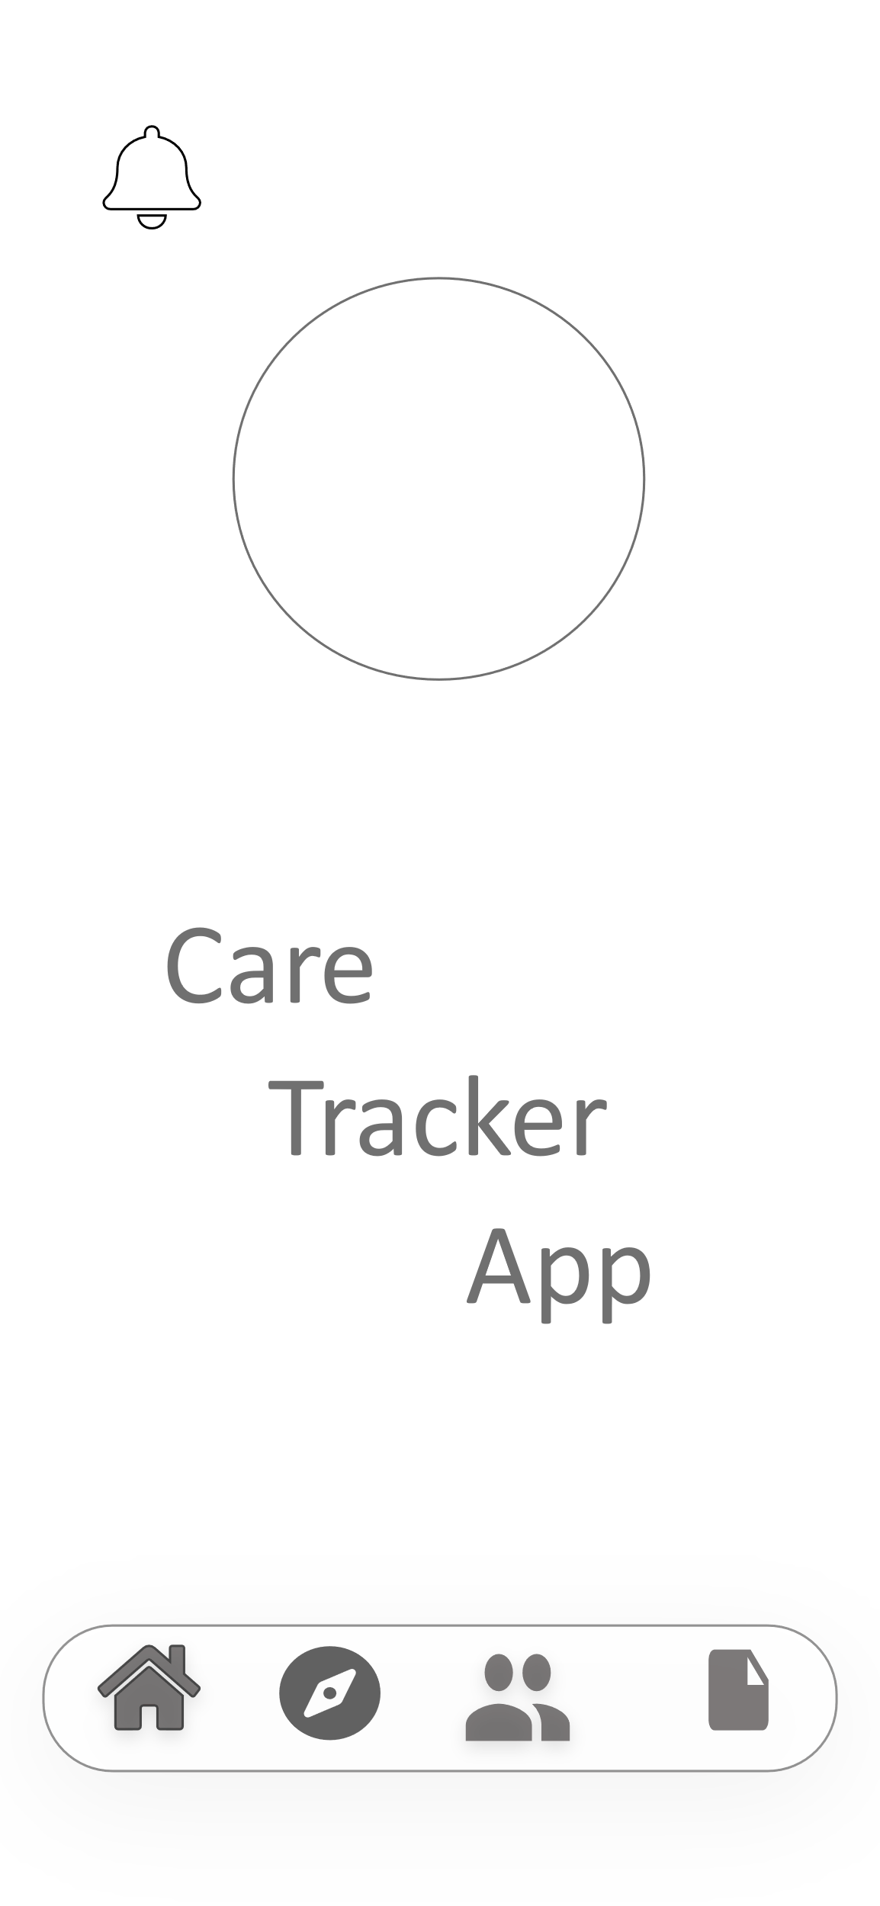

The is the Home interface which is related to Carer and this ran using the navigation bar split onto their respective parts including

* Home
* Tracker
* Profile
* Planner

Icons such as the bell takes you to view the notification where you can view messages from the client.

***The Link to view the full video is here***

https://youtu.be/kASPn-ij_Co

**End Users of Application**

Our vision for our UI as a group was to focus on Simplicity whilst completing the purpose the application. By simplifying the scope of the app, it has affected the UI and made it extremely easy to move around the interface. When building this application, we had to ask ourselves who is our scope / niche group that would be using this app. We can all fall into the stereotype of saying that people who needs care are elderly or that their not considered as “Tech Wizards” and vis versa when talking about younger clients but this was where we needed to eliminate those stereotypes as it doesn’t help. So, by eliminating those thought we decided that the app would be focused on people that need care.

The bases of this project being the Care Tracker App is to provide a protection and care over others and we have tried to implement that through this app by providing data such as ,  a planner that the client can use to detail there activities for the day , a help button used to signal if the client is in distress and finally a profile page detailing the clients history and telling the carer more about it client.

These bases can also be shared in the eyes off the carer themselves. Their job is to provide care to these clients and ensure their safety. This type of data has been also implemented through this app by having a tracker (this requests the client’s permission) that allows you to know where the client is when they are lost or distressed. The carer can view the clients’ planner and view the history of their client also.

The Care Tracker App is aim towards the relationship of the client and carer and these are the main users of the device. A client is as equally important to the career as to the carer to the client. They both work together to sustain a healthy balance.

**User Stories**

**Story 1 Title:** Alert Carer

**Description:**

As a client

I want to be able to alert my carer

so that if I signal for help, they can respond

**Acceptance Test:**

Open Care Tracker App, Select Help Button, Display Warning.

Click the Agree Button, Request is Sent.

**Estimate: round** **1:** 1,3,5,2,1, **round 2:** 1,2, 1, 3, 1 **Consensus 2**

**Story 2 Title: Add activity**

**Description:**

As a client …

I want to add an activity to my planner

so that my client is aware of where I will be

**Acceptance Test:**

**Scenario 1**

Open Care Tracker App, Press the Plus Button, Enter the details of Activity,

Press the Add Button

**Scenario 2**

Open Care Tracker App, Select the Planner button, Press the Plus Button,

Enter the details of Activity, Press the Add Button

**Estimate 1: round 1**: 1,3,5,2,1, **round 2**: 1,2, 1, 3, 1 Consensus 2

**Estimate 2: round 1:** 1,3,5,2,1, **round 2**: 1,2, 1, 3, 1 Consensus 2

**Story 3 Title: View Profile**

**Description:**

As a carer …

I want to be able to view my clients’ profile

so that I can find out more about my client

**Acceptance Test**:

Open Care Tracker App, Select Profile Icon

**Estimate**:1,1 **Consensus:** 1

***Persona***

***Career***

***Siobhan, carer of a 65-year-old client***

Siobhan is a 25-year-old carer who just finished college and is now doing her first job in a carer home. She has been tasked to take care of John who is a 65-year-old client suffering from dementia. It takes her almost 2 hours to commute from Kildare to Ardee to be able to work. Siobhan must take good care of him, she (as the carer) will sign john (as the patient) to the care tracker app as it easier for her to keep track of john.

By signing him up he can let his carer know about his where abouts and possible problems when she is not available/ around.

**Users Details**

Name: Siobhan Kerr

DOB: 10th September 1995

Occupation: Carer

Carer Home: Ardee Care Home

Patient: John Stacy

Age: 55 years

Illness: Dementia

**Siobhan's Goals**

• It ensures John that suffering with dementia is safe at all cost

• Her goal with the care tracker app is to be able to monitor John knowing she will not be around him most of the time so it would help her keep informed

• By selecting the Care tracker App, John will be able to let Siobhan know his whereabouts without her having to worry about it.

• Siobhan is also able to look at John’s planner and see what he has planned for the day or the week.

**Interface Requirements**

• Allows to tracker

• Provide a planner

• Minimise obsolete screens making user interface nice and easy for both users

• Allow Carer to be able to accesses information

***Persona***

***Client view***

***Maire, newly retired labourer***

Marie is a 67-year-old newly retired labourer who stays in Cork after working in a factory for 40 years has been suffering from diabetes. Her Carer which is Philip is usually her stay at home carer but he decided to go and visit his family for the weekend and fears that Maire may be in danger as her vision and hearing has started to deuterate which impedes her daily. As Maire is aware, she hears about this app that her friend Mildred uses to keep in contact with her career. She hears it is called Care Tracker App and it is as simple to use with a 4-part navbar so if she needs to contact Phillip it is at a touch of a button. She signs up and tells Phillip to set up one as the carer. This way she can keep in contact with Phillip and he can give her instruction on prescriptions

**Users Details**

Name: Maire Stacy

DOB: 14 Feb 1951

Age:67 years

Address: 22 Manor Road

Illness: Diabetes

Career: Phillip Mc Donald

**Maire Goals**

• It ensures that she can still receive instruction from Philip to be able to know which prescription to take

• Her goal with the care tracker app is to be able to keep in contact with Phillip whilst he is visiting homed

• By selecting the Care tracker App, Maire will be able to let Phillip know her whereabouts without him having to worry about it.

**Interface Requirements**

• Allows to tracker

• Provide a planner

• Minimise obsolete screens making user interface nice and easy for both users

• Allow Carer to be able to accesses information

**Testing**

***How to tell if the project is successful or not.***

To dictate whether this project is either successful or unsuccessful, testing will be vital. The type of testing we have decided to use is user testing and usability testing. User testing is an important method to be implemented within the application. This will ensure that the project is successful and meets the functional requirements in relation to the User Interface.

Usability testing is a form of user testing which examines how the customer can use the application that we produce. User testing will be essential on both interfaces to find any usability issues.

An example of testing the UI in our project would be clicking a button and seeing if it performs the functional requirement it was given.

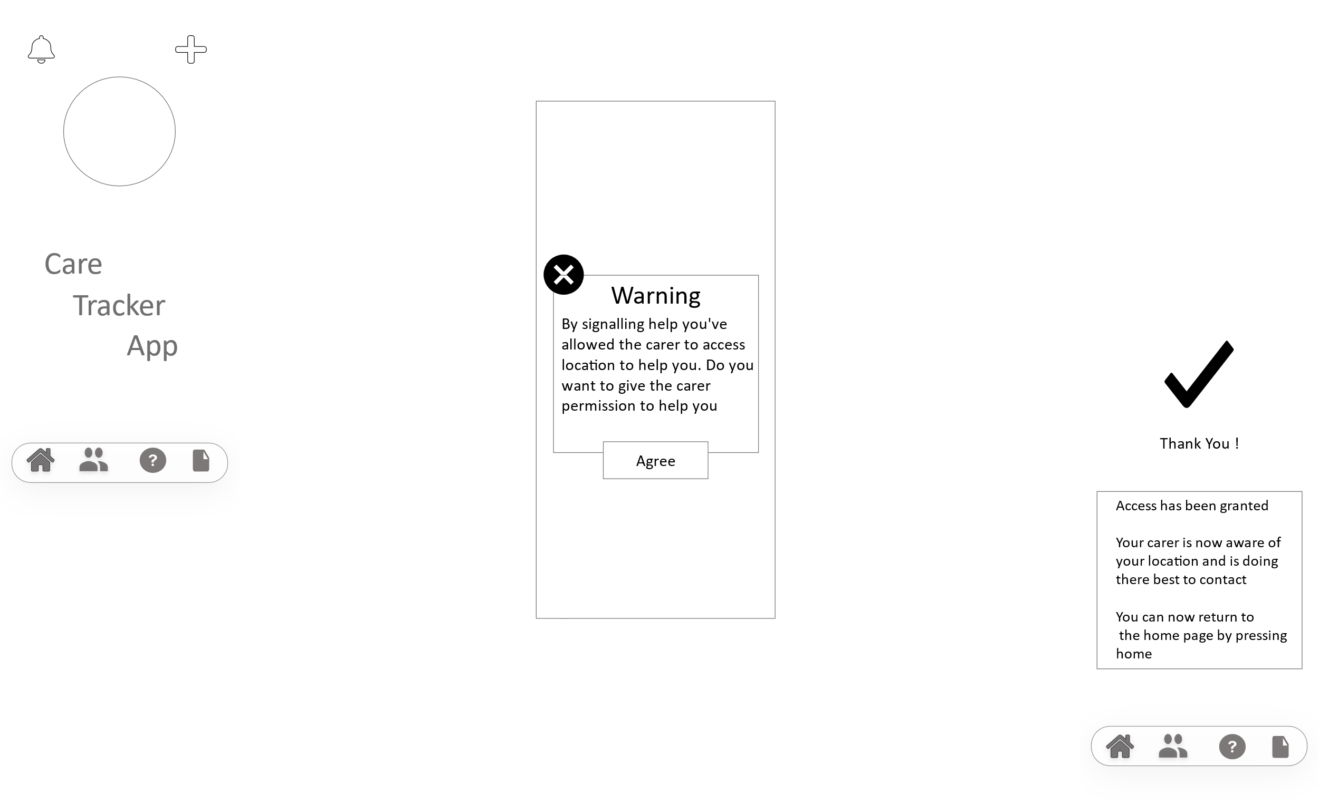

(Figure (X.X.X) – Help icon process)

In this example the diagram above shows how when the client clicks the “help” icon the purpose of the button is to alert the carer that the client may be lost or needs help. When this functionality is added in the application it will be tested to see if it does what it is meant to do. The continuous flow of testing will lead to a successful project.

The diagram below illustrates the relation between user and usability testing.

Usability Testing vs User Testing

Satisfaction

Memorability

Desirability

Credibility

Roadmap

Validation

Compatibility

Test Support Processes

(Figure. X.X.X – Relation between usability and user testing)

Our application consists of two interfaces which are illustrated in the UI design. The UI of the client side of the application has been designed to be simple and easy for the user to use. User testing will determine if this is true which will lead the application to become successful. Nevertheless, the UI of the client side has also been designed to be made easy to use, which will also be tested.

The testing of the application will begin around the middle stage of the design of the UI. The reason being is to check that features are working as they are added. By doing this time is being used wisely and will leave less issues to be resolved towards the end of the project. By carrying out user and usability testing for all features within the application, will lead to the success of the project.

Reference for diagram

( <https://www.google.com/url?sa=i&url=https%3A%2F%2Fblog.hubspot.com%2Fservice%2Fuser-testing&psig=AOvVaw1WfetmUemuIkP95sn5f-ih&ust=1605449660528000&source=images&cd=vfe&ved=0CAIQjRxqFwoTCMDGy5-cgu0CFQAAAAAdAAAAABAw> )